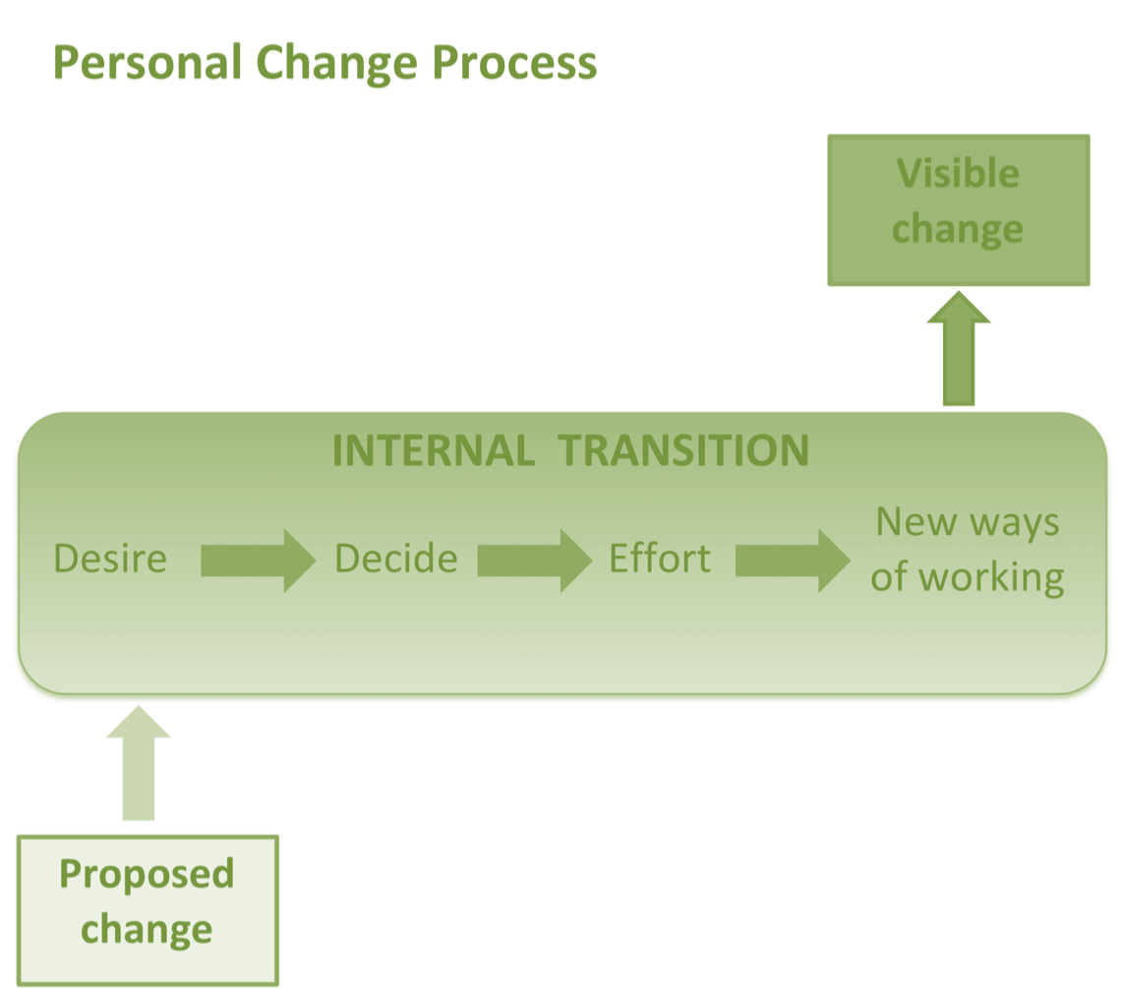

A common mistake is to assume that just by building awareness of the need for change you have also created desire.

Knowing that there is an issue is very different from committing to resolve it.

Personal change is not easy, and takes a lot of effort.
People need reasons to make the effort, and to keep going when the going gets tough.
Motivation for change must be generated before change can occur
Kurt Lewin

MOTIVATING CHANGE
Select one or more of the approaches below to generate desire and motivation for change
Look back to look forward
Spend as much time as you need in the past to determine what is important to the person.
Understand their journey to the current crossroads.
What has happened in the past?
What are they letting go of?
What are their fears or barriers?
Pros and cons
Discuss change vs staying the same. Help them make a list of pros and cons for each
Pros:
What looks appealing about this choice?
What are the advantages?

Cons:
What is bad about this choice?
What are the disadvantages?
What are the barriers or challenges for this choice?
Three scenarios
ASK them to imagine and describe:

Best case scenario

Worst case scenario

Interesting case scenario

